 **SIMATS ENGINEERING**

**SAVEETHA INSTITUTE OF MEDICAL AND TECHNICAL SCIENCES**

**CHENNAI-602105**

**CSA0937-PROGRAMMING IN JAVA FOR EVENT HANDLING**

**PROJECT**

**PROGRAMMING IN JAVA**

Java –Airline Reservation System

*Submitted By*

**P.V.Manvitha(192111208)**

*in partial fulfillment of the requirements*

*For the award of the degree*

*Of*

**BACHELOR OF COMPUTER SCIENCE ENGINEERING**



**Institute of Computer Science and Engineering**

**SAVEETHA SCHOOL OF ENGINEERING CHENNAI-602105 TAMILNADU**

**, INDIA**

**Index page**

|  |  |  |
| --- | --- | --- |
| **S.NO** | **TOPIC** | **Page No** |
| 1 | OBJECTIVES | 3 |
| 2 | GANTT CHART | 4 |
| 3 | INTRODUCTION | 5 |
| 4 | LITERATURE SURVEY | 6-7 |
| 5 | DESIGN | 7 |
| 6 | ANALYSIS | 8 |
| 7 | RESULT | 9 |
| 8 | CONCLUSION | 9 |
| 9 | REFERENCES | 9 |

**Airline Reservation System**

Guru chandu P1),Manohar P2) and Mohamed Haneef S3)

*Institute of computer Science and Engineering,Saveetha School of Engineering,SIMATS*

*Chennai,India*

# Objectives :-

The objectives of an “**Airline Reservation System”** are multifaceted, aiming to streamline the booking process, enhance customer satisfaction, and optimize operational efficiency. Firstly, such a system seeks to provide a user-friendly platform for travelers to effortlessly search for flights, compare prices, and make reservations, thus simplifying the booking process and reducing the time and effort required. Additionally, it aims to ensure accuracy in reservations and minimize errors, thereby enhancing customer satisfaction and trust in the airline's services.

Furthermore, an effective reservation system should facilitate efficient management of flight schedules, seat availability, and passenger data, enabling airlines to optimize their resources, maximize revenue, and improve overall operational efficiency. Moreover, it should incorporate features such as secure payment processing and data encryption to safeguard sensitive information and ensure the security of transactions. Overall, the primary objectives of an Airline Reservation System are to enhance the customer experience, streamline operations, and drive business success in the competitive aviation industry.

In addition to the core objectives mentioned earlier, an Airline Reservation System plays a pivotal role in enabling airlines to adapt to dynamic market conditions and evolving customer preferences. By leveraging advanced analytics and data-driven insights, these systems empower airlines to make informed decisions regarding pricing strategies, route optimization, and capacity planning. By analyzing historical booking patterns, market trends, and competitor strategies, airlines can adjust their pricing dynamically to maximize revenue and fill flights optimally.

# Gantt Chart:-

|  |  |  |  |
| --- | --- | --- | --- |
| TASK | TIME DURATION  DAYS | START DATE | END DATE |
| Project Plannig | 1 | 03-02-2024 | 03-02-2024 |
| Requirements Gathering | 1 | 04-02-2024 | 04-02-2024 |
| User interface implementation | 2 | 05-02-2024 | 06-02-2024 |
| Airline reservation development | 4 | 07-02-2024 | 10-02-2024 |
| Security testing | 2 | 11-02-2024 | 12-02-2024 |
| Documentation | 1 | 13-02-2024 | 13-02-2024 |
| Project review | 1 | 14-02-2024 | 14-02-2024 |

## Introduction :-

In science and technology, the desire for improvement is a constant subject which triggers advancements. This is visible in every ramification and the airline industry is not an exemption. Airline reservation systems were first introduced in the late 1950s as relatively simple standalone systems to control flight inventory, maintain flight schedules, seat assignments and aircraft loading. Today modern airline reservation systems are comprehensive suites of products to provide systems that assist with a variety of airline management tasks and service customer needs from the time of initial reservation through completion of the flight.

The World Wide Web has become tremendously popular over the last four years, and currently most of the airlines have made provision for online reservation of their flights. The Internet has become a major resource for people looking for making reservations online without the hassle of meeting travel agents by implementing an online reservation system this ensures that reservation are not only generated by the airline own staff but also by any travel agent using a Global Distribution system or other airlines that have a multilateral Interline Traffic Agreement with the airline.

At its core, an airline reservation system allows travelers to search for flights, compare prices, select seats, and make bookings through various channels such as airline websites, mobile apps, or third-party travel platforms. These systems are designed to handle a vast amount of data in realtime, including flight schedules, seat availability, fares, and passenger preferences

Behind the scenes, sophisticated algorithms and databases work tirelessly to manage inventory, optimize flight schedules, and ensure efficient resource allocation. From ticketing and check-in to boarding and baggage handling, the reservation system coordinates every aspect of the passenger journey to deliver a seamless and enjoyable travel experience.

Moreover, modern reservation systems often incorporate advanced features such as loyalty programs, ancillary services (like seat upgrades and meal preferences), and integration with other travel-related services such as hotel bookings and car rentals. This holistic approach not only enhances customer satisfaction but also contributes to the overall profitability and competitiveness of airlines in the global market.

This includes flight schedules, seat availability, fares, and passenger preferences, all of which must be coordinated seamlessly to ensure a smooth and efficient travel experience. Moreover, modern reservation systems have evolved to offer advanced features such as loyalty programs, ancillary services, and integration with other travel-related services like hotel bookings and car rentals. This holistic approach not only enhances customer satisfaction but also enables airlines to maximize revenue and efficiency.

## Literature Survey :-

**O.M. Olaniy** et al. Airline Reservation in developing countries is carried out either manually or electronically. Either methods, reservation and payment operations are done in piece-meal fashion; this is cost prohibitive, time consuming and tedious leading to inefficiency. We present an integrated mobile airline reservation and payment system. Ours is a Client/Proxy/Server system with the proxy layer serving as mobility-aware middle layer providing real-time self service support.

**Duncan G. Copeland** et al. In this work evolutionary perspective reveals interdependent industry, company, and technology forces that shaped the pattern of competition. Although many facets of the airline experience are unique to the air transport industry, the authors identify three features with broad implications for the strategic use of information technology. Finally, sustainable advantage need not be the result of extraordinary vision, but the result of consistent exploitation of opportunities revealed during the evolution of adaptable system. This article documents each stage in the evolution of reservations systems--from their inception as manually maintained inventories of seat availability, through their description as "anticompetitive weapons" used unlawfully to obtain and exercise monopolistic power.

**Oyelade O. J** et al. The objective of this paper is to develop a mobile airline seat reservation system that will assist the public in gaining an easier and faster way for seat reservation and providing them with more options to book a ticket for traveling on real time. The system was developed using the Wireless Markup Language (WML) as frontend, MySQL 4.0 database management system as back-end and PHP (Hypertext Preprocessor) as the server-side scripting language. The developed system will assist the airline customers and operators in providing costeffective system that will make possible bookings and seat reservation on real-time using a mobile phone, irrespective of location of a user.

**Harini Mohan** et al.The main objective of the Airlines reservation system is to implement software using java that accompanies blockchain technology considering the airline sector challenges. It helps users to reserve tickets for air service and track the updated status periodically. Blockchain technology keeps the data secured and centralized providing efficient usage via mobile apps or online. The system provides an efficient user interface for both customers and stakeholders and analyzes the behavior of the customer and provides efficient results. This article also explains the demand price prediction and related challenges to be solved efficiently. All the above factors are considered and an efficient solution of application system using Java.

[**M Sakthimohan**](https://ieeexplore.ieee.org/author/37086345268) et al. The usability of an online airline reservation system cannot be predicted without considering the flexible behavior of travelers. However, travelers' flexible behavior is molded by a number of service quality attributes. In this paper, service quality attributes along with external variables were computed to determine their association with flexible behavior of travelers and to also ascertain their individual range and strength of association. Pearson Correlation Coefficients and Multiple Regression Analysis was computed using the ten servce quality attributes along with external variables to determine their association with flexible behavior of travelers. The results showed that all of these correlations are statistically signifícant.

[**Tara Singh Naik**](https://ieeexplore.ieee.org/author/37089294791) et al. Airlines use various kinds of computational techniques to increase their revenue such as demand prediction and price discrimination. From the customer side, two kinds of models are proposed by different researchers to save money for customers: models that predict the optimal time to buy a ticket and models that predict the minimum ticket price. In this paper, we present a review of customer side and airlines side prediction models. Our review analysis shows that models on both sides rely on limited set of features such as historical ticket price data, ticket purchase date and departure date. Features extracted from external factors such as [social media data](https://www.sciencedirect.com/topics/computer-science/social-medium-data) and search engine query are not considered. Therefore, we introduce and discuss the concept of using social media data for ticket/demand prediction**.**

**DESIGN :-**

In this phase initially I had designed E-R diagram of the processes , in order to identify various entities and relation ship set ,entity set ,attributers, link attributes The Diagram of this process as under.

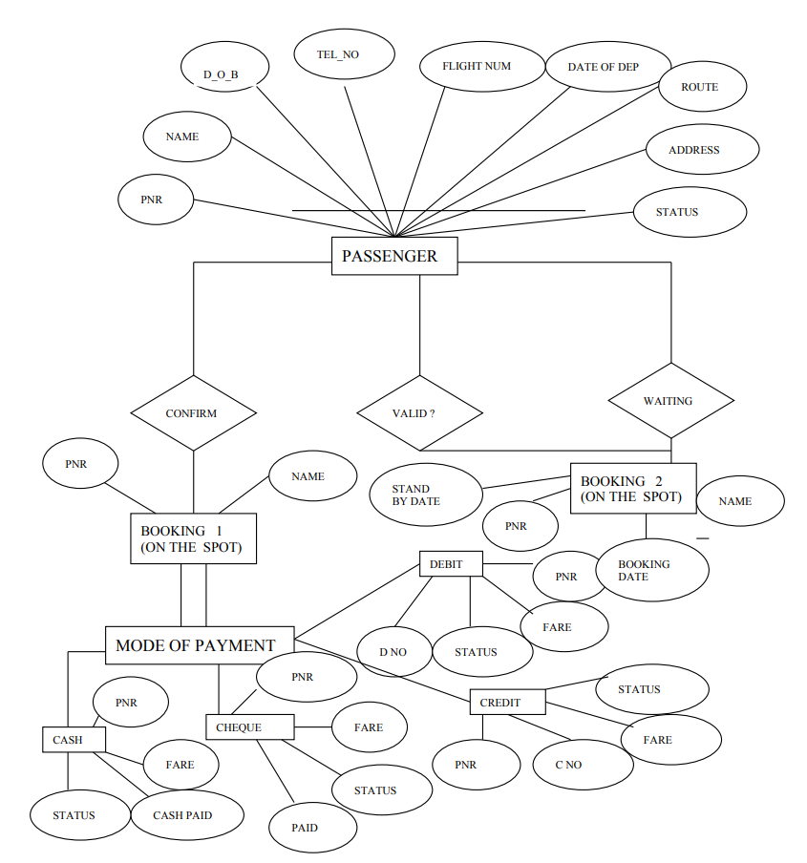

## Analysis:-

The Airline Reservation System (ARS) serves as the backbone of the aviation industry, offering a comprehensive suite of functionalities to streamline the booking process for travelers worldwide. It facilitates every step of the journey, from flight search and seat selection to reservation confirmation and payment processing.

**Java code**

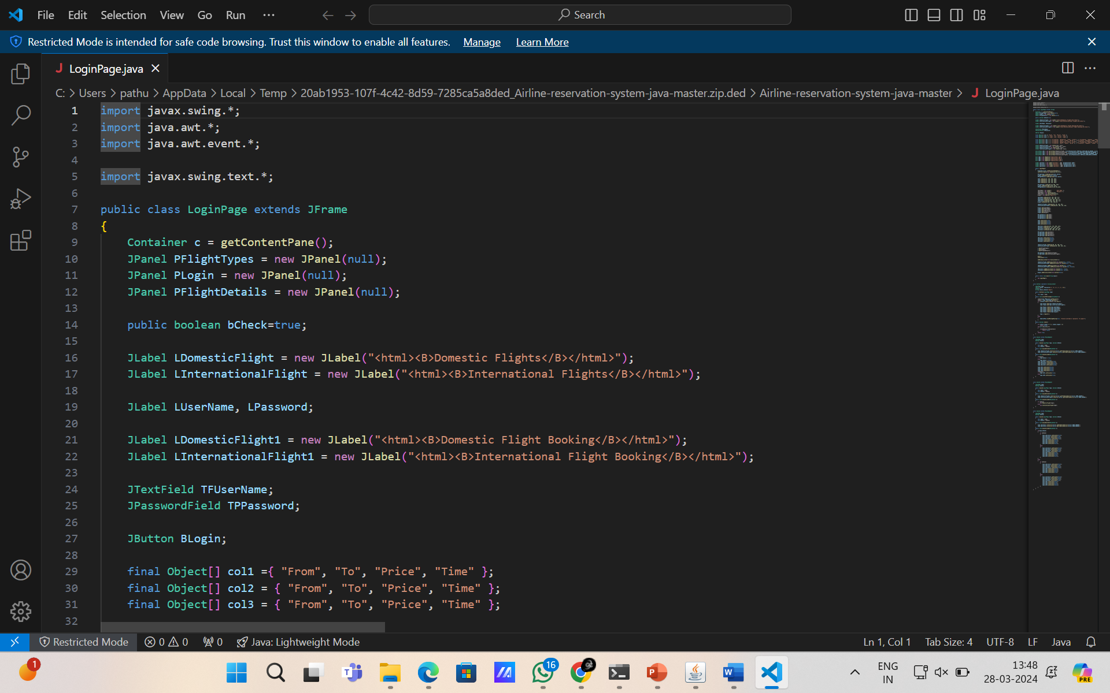

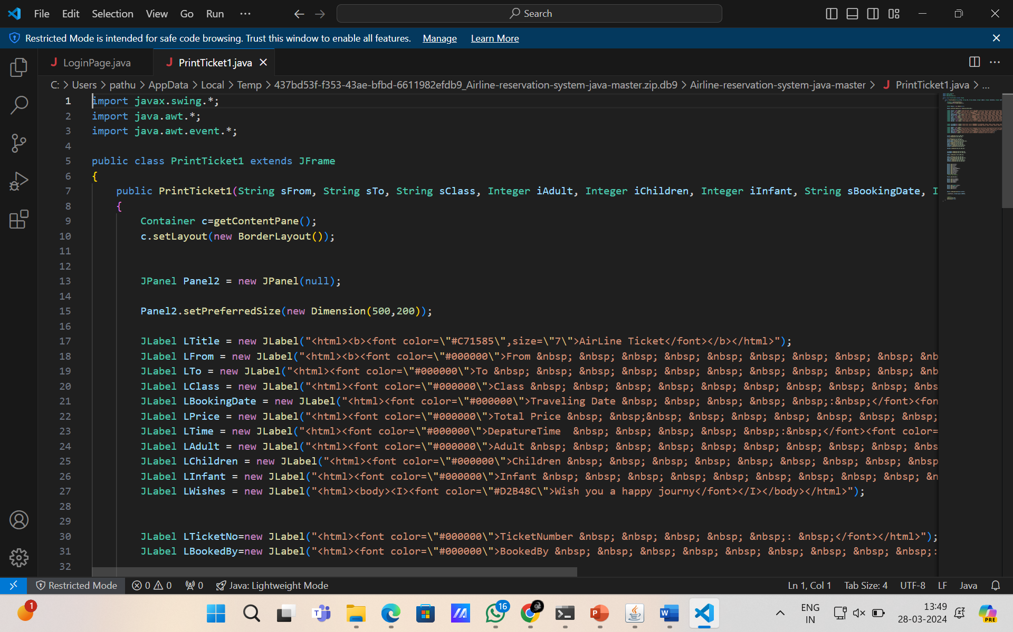

## Result:-

In summary, the Flight Reservation System plays a crucial role in the aviation industry by enhancing the user experience, improving operational efficiency, and optimizing revenue for airlines. As technology continues to evolve, FRS will remain a key enabler of seamless and efficient air travel experiences for passengers worldwide.

The Flight Reservation System (FRS) serves as a critical component in the aviation industry, facilitating the booking process for air travelers and enabling airlines to manage their operations efficiently. Here are some key results and insights regarding the Flight Reservation System:

## Conclusion:-

Though the system still containing lot of scope of improvement in it. But its overall look and feel gives rough picture of on existing automation system. I have take MS-Access at backhand but it has a limitation of 1 GB size .It over data size approaches this 1gb some other database the SQL server ,oracle, can be used with OBBC to break this barrier.

In conclusion, the Airline Reservation System (ARS) stands as a cornerstone of modern air travel, offering a seamless and efficient platform for both passengers and airlines. Through its comprehensive functionalities, ARS simplifies the booking process, enhances operational efficiency, and improves the overall travel experience.

## Reference :-

Olaniyi, O.M., Ajose, S.O. and Adegoke, M.A. (2010) ‘Development of a mobile airline reservation and payment system’, Int. J. Electronic Finance, Vol. 4, No. 4, pp.372–389.

Doty, L. "Scorecard Shows Some Big Gains, Some Losses," Aviation Week & Space Technology, October 22, 1973, p. 41. Duffy, W.J. "Analysis of American’s and United’s Statements Regarding the Profitability of SABRE and APOLLO," Simat, Helliesen & Eichner, Inc., May 1985. Eastern Airlines, Inc. Annual Report, 1968. Economist. "Sabre Rattling," November 7, 1987, pp. 72-73

Tarasewich P., Nickerson R. C. and Warkentin M. (2002), ―Issues In Mobile E-Commerce‖, Communications of the Association for Information Systems, Vol. 8, pp. 41-64.

Zhao Wei, Rongsheng Dong, Xiangyu Luo and Fang Liu, "Model Checking Airline Tickets Reservation System Based on BPEL", *2009 Third International Conference on Genetic and Evolutionary Computing*, pp. 1-6, 2009

Arif Mushtaq and Sadia Riaz, "Flexible airlines reservation systems using service quality attributes of airelines", *2016 Sixth International Conference on Innovative Computing Technology (INTECH)*, pp. 1-5, 2016..

Laurie A. Garrow, Matthew J. Higgins

Estimating flight-level price elasticities using online airline data: a first step toward *integrating* pricing, demand, and revenue optimization